**National University of Computer & Emerging Sciences, Karachi**

**Artificial Intelligence-School of Computing**

**Fall 2023, Lab Manual – 01- Installation Guide**

|  |  |
| --- | --- |
| **Course Code: CL-2005** | **Course: Database Systems Lab** |
| **Instructor(s):** | **Sohail Ahmed Malik, Mr. Mubashir, Mr. Sameer Faisal, Ms. Mehak Mazhar, Ms. Fatima, Ms. Mahnoor Javed, Ms. Filza Akhlaq, Ms. Bushra Sattar, Ms. Ravia Ejaz, Ms. Yumna Asif** |

Contents:

1. Installation Link: https://drive.google.com/drive/folders/1a2agl45zMwJIUHUSBmC1kc-S_nM19t_z?usp=sharing

Installation

Step#01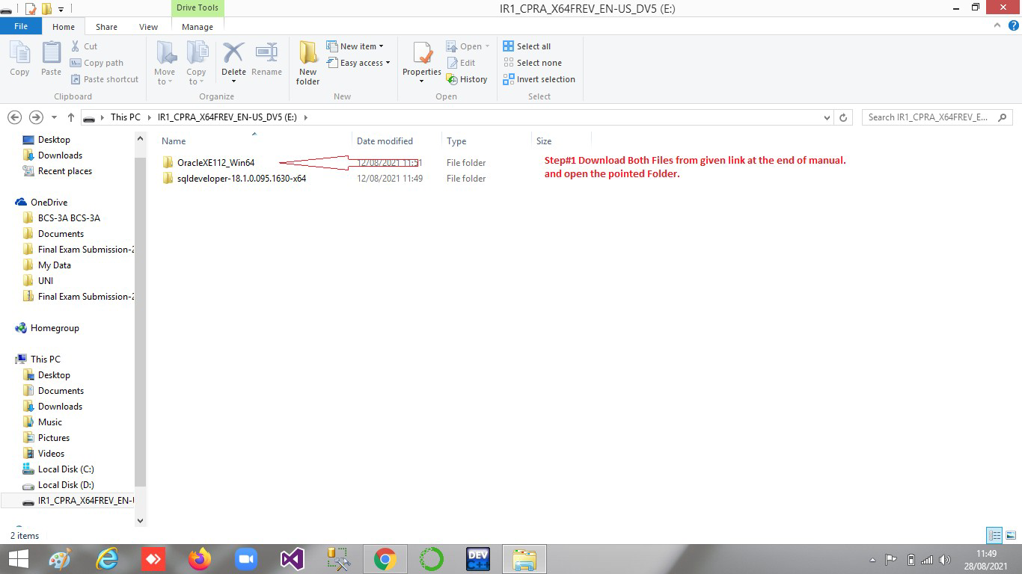

Step#02

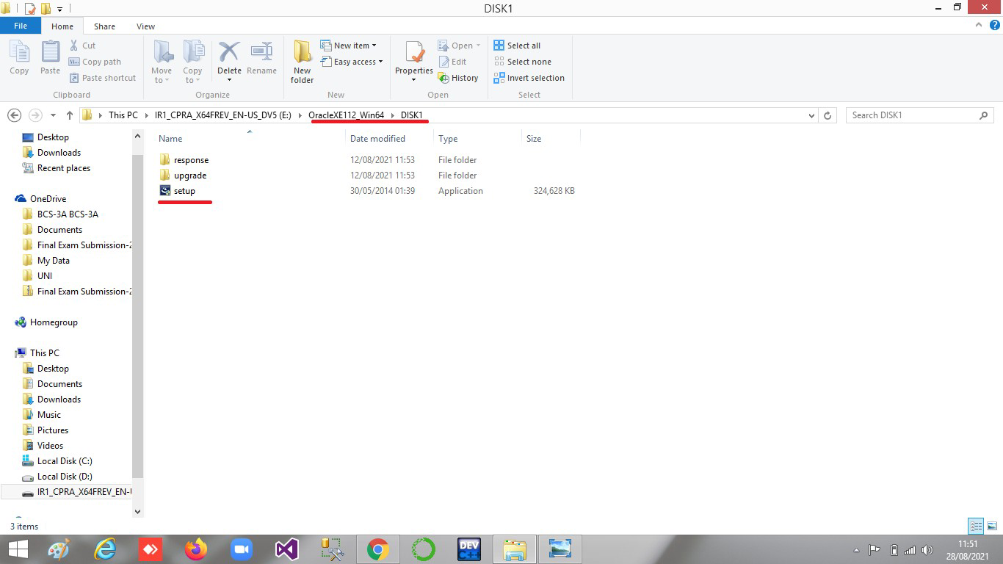

Step#03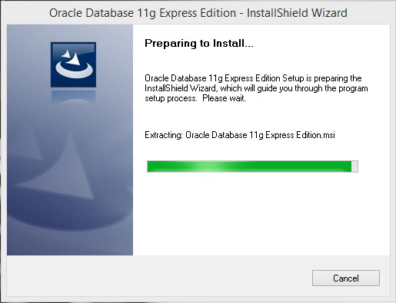

Step#04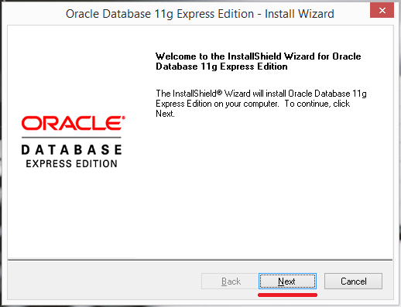

Step#05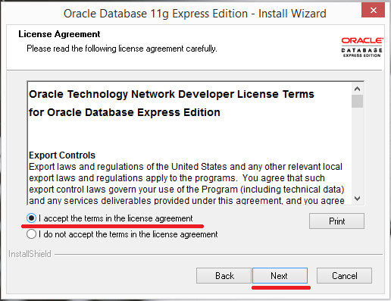

Step#06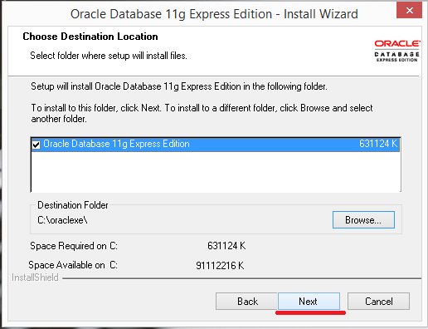

Step#07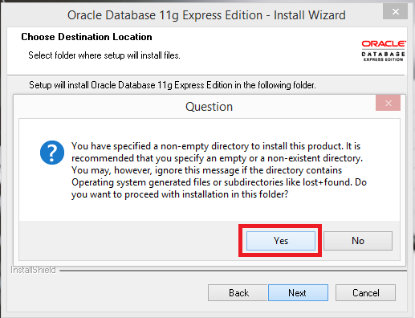

Step#08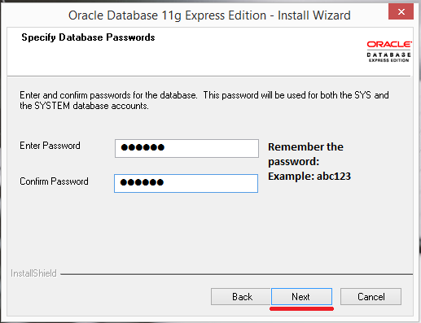

Step#09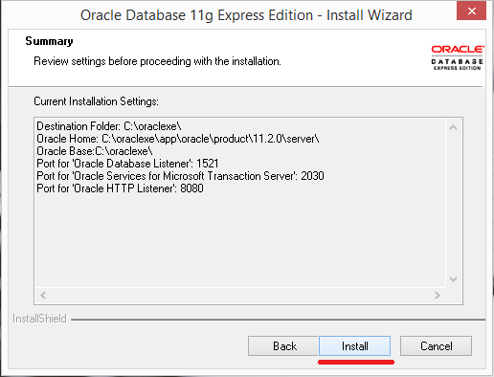

Step#10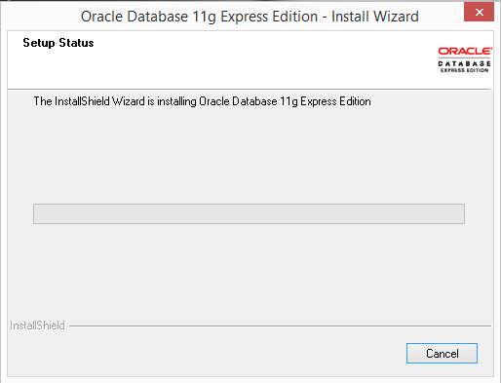

Step#11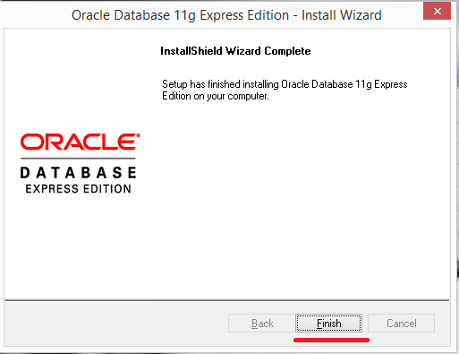

Step#12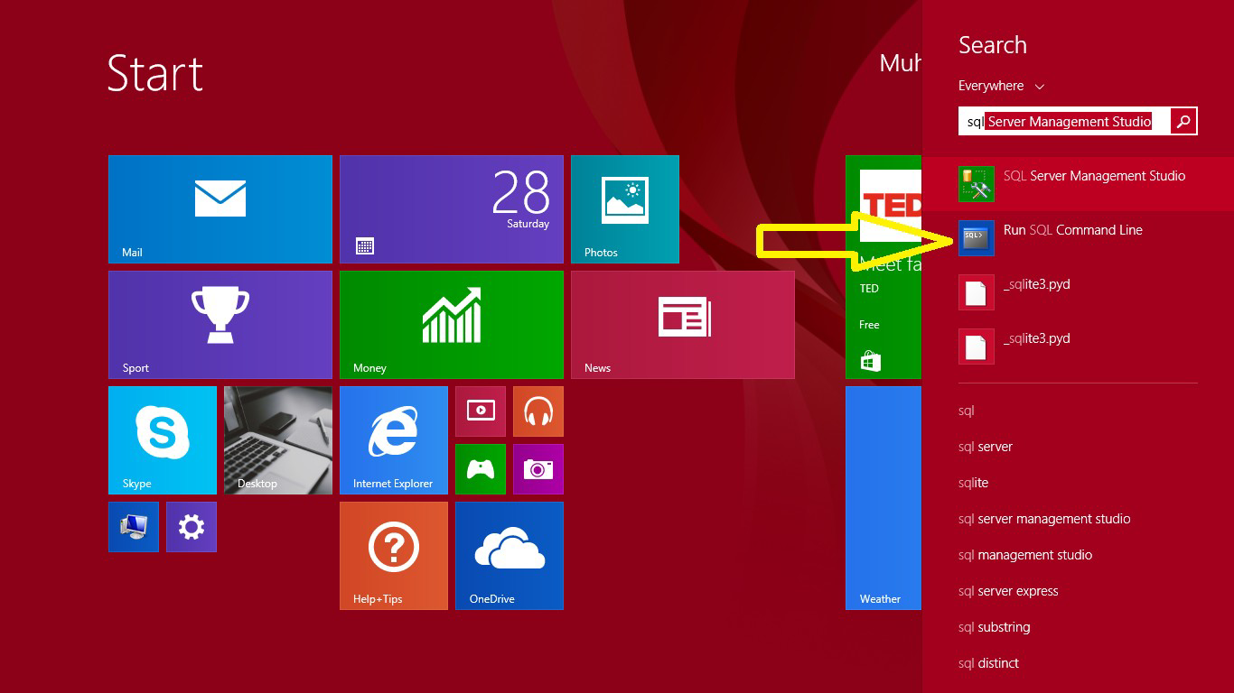

Step#13

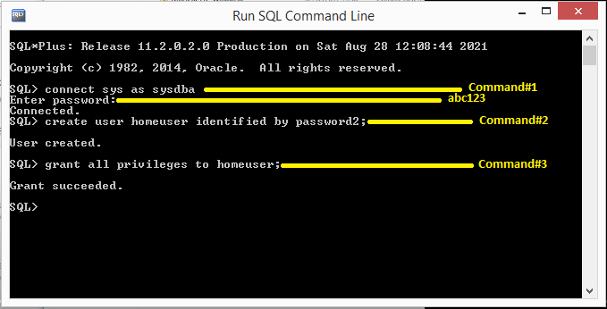

Step # 14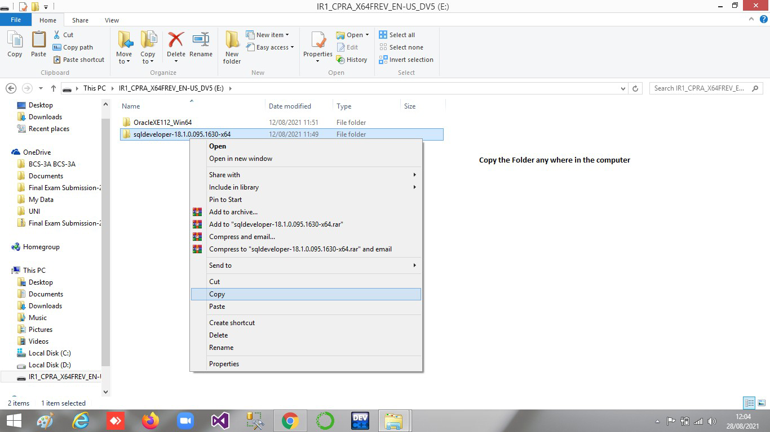

Step#15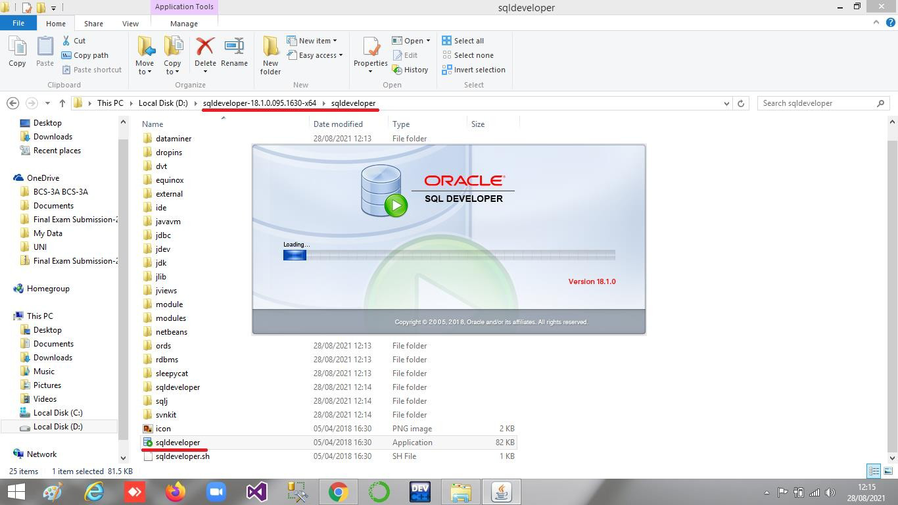

Step#16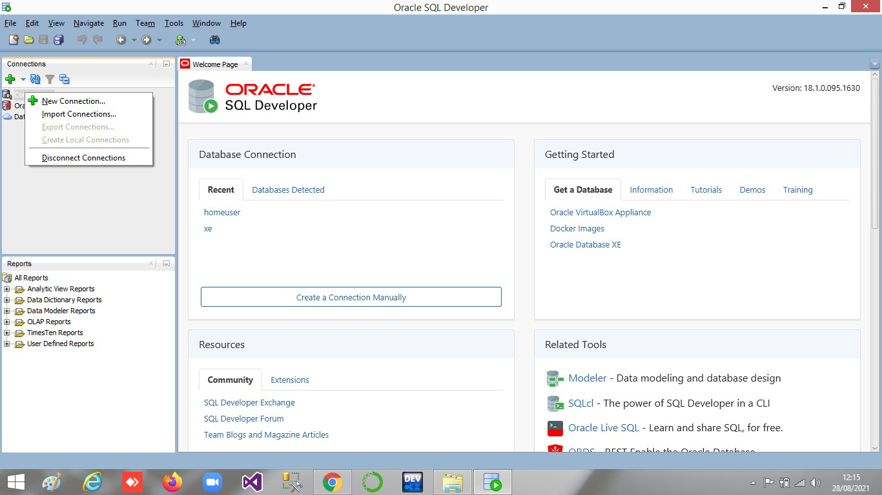

Step#17

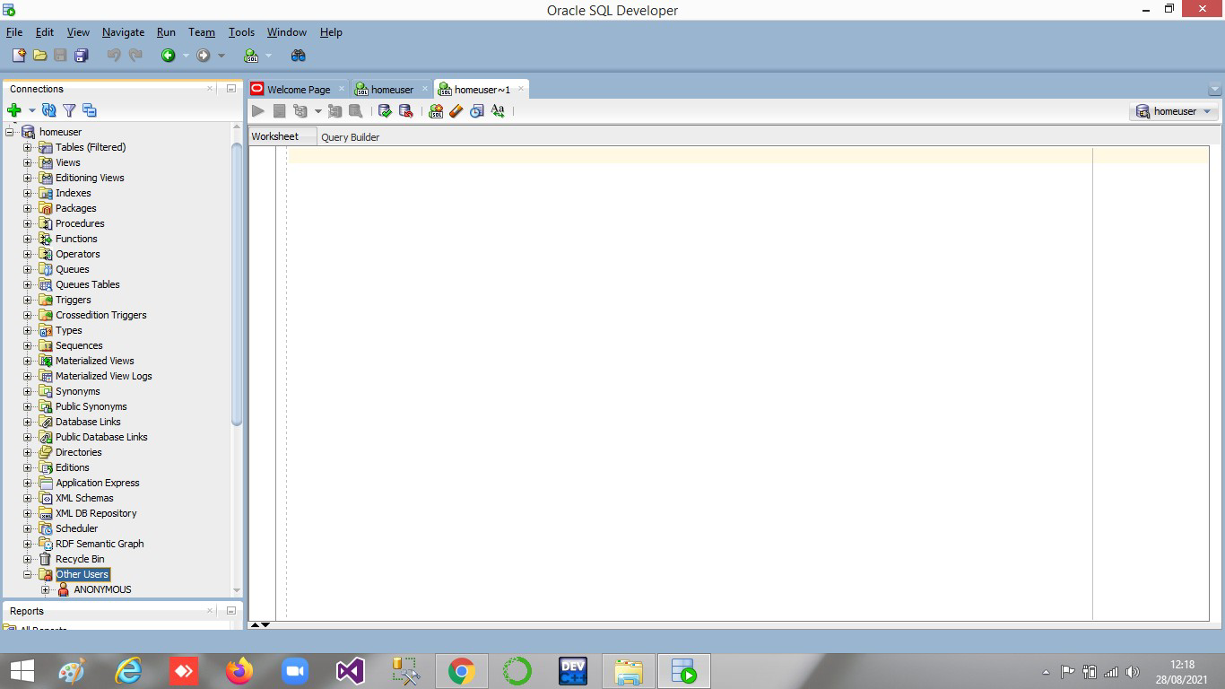

Step # 18

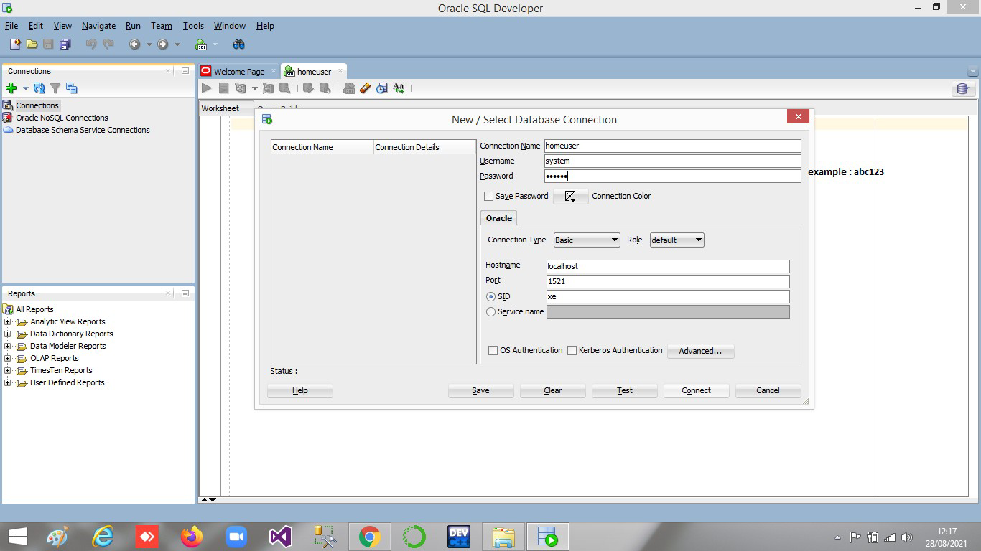

Step#19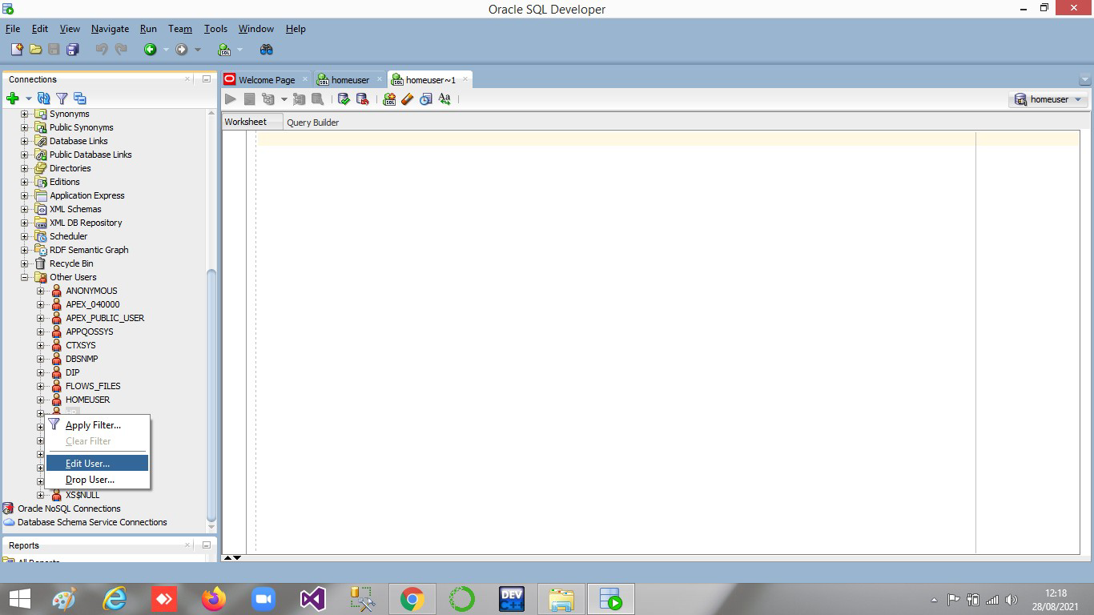

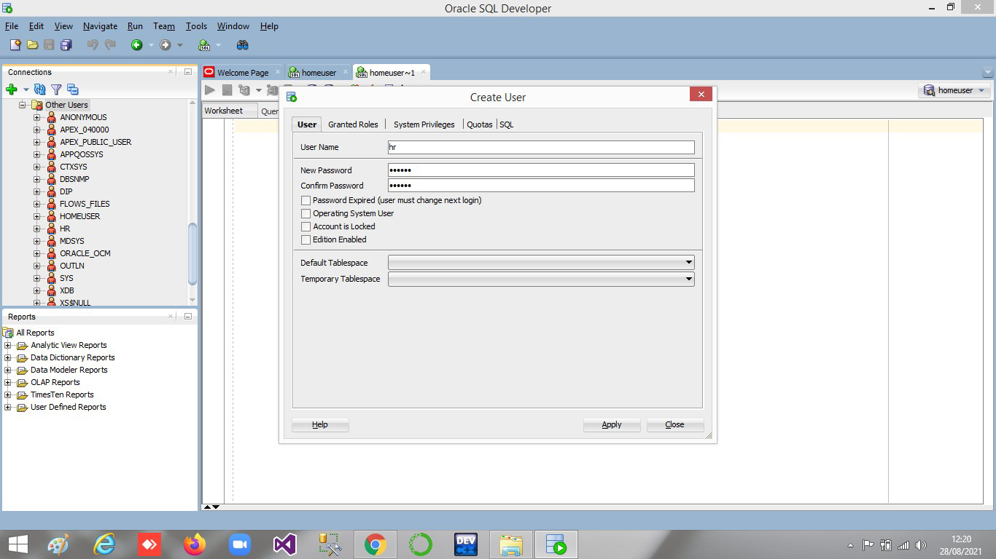

Step#21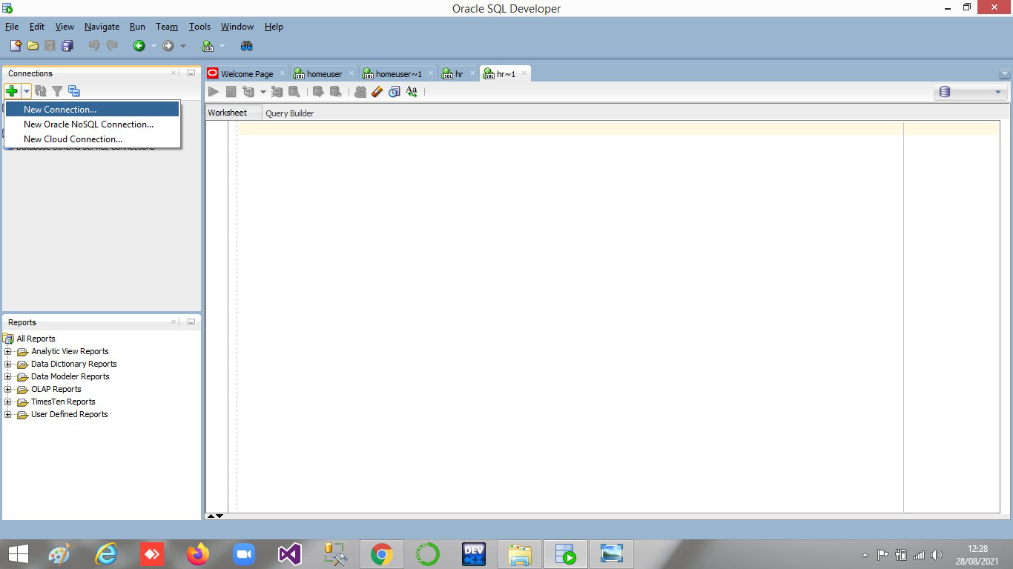

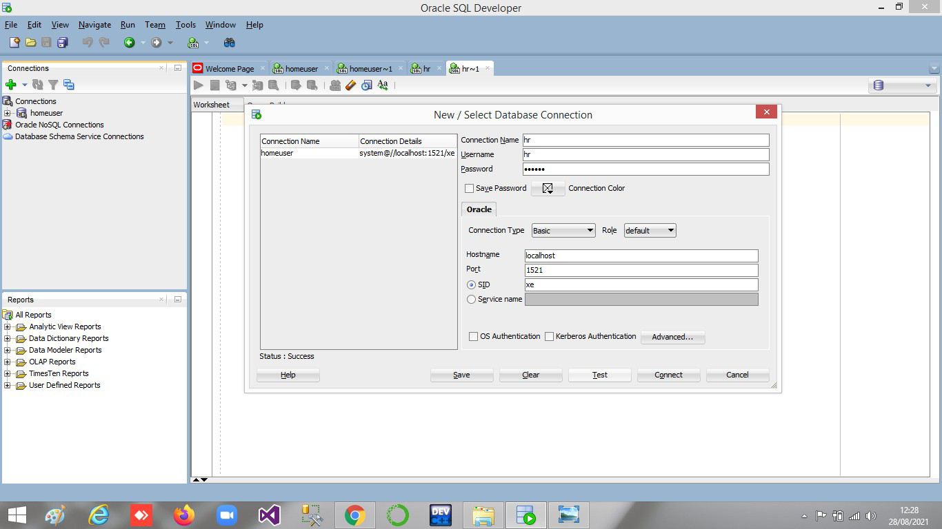

Step#23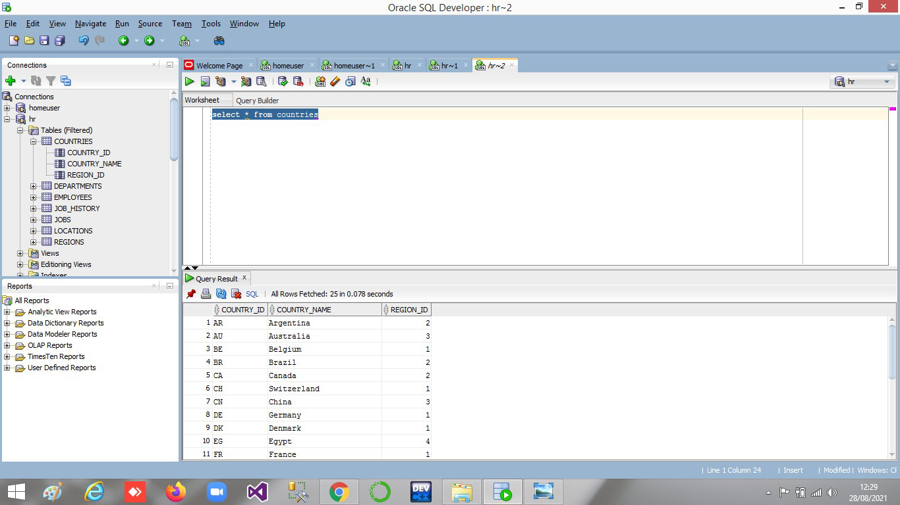

**Oracle & SqlDeveloper Download Link** [**https://drive.google.com/drive/folders/1a2agl45zMwJIUHUSBmC1kc-S_nM19t_z?usp=sharing**](https://drive.google.com/drive/folders/1a2agl45zMwJIUHUSBmC1kc-S_nM19t_z?usp=sharing)

**-----------------------------END-----------------------------**